**MOTION DETECTOR IOT SMART DEVICE:**

**AQSA AHMAD**

**EL – 19020**

**SECTION A**

**1. Initialization:**

- Set up the network topology in Cisco Packet Tracer, including the home gateway, motion detector, siren, webcam, and tablet.

- Configure IP addresses, subnet masks, and routing on the network devices.

**2. Motion Detector:**

When motion is detected, trigger an event to activate the siren and start recording video on the webcam.

**3. Siren Activation:**

- Upon receiving the motion detection event of thief or anyone, a signal is sent to the siren device to activate it.

- This can be achieved through the appropriate network communication, such as sending a command or signal to the siren device's IP address.

**4. Webcam Recording:**

- When motion is detected, it should initiate the recording process on the webcam device.

- This can involve capturing video frames from the webcam and storing them locally or sending them to a designated storage location.

**5. Home Gateway:**

- The home gateway provides internet access to the connected devices, including the tablet.

- The home gateway should be properly configured to allow communication between the motion detector, siren, webcam, and tablet.

- Configure any necessary port forwarding or firewall rules to enable communication with external devices or remote monitoring.

**6. Tablet Monitoring:**

- The tablet acts as a monitoring device for the security system.

- Tablet establish a connection with the home gateway and receive notifications or video streams from the motion detector and webcam.

- Real-time alerts or notifications can be displayed on the tablet's screen when motion is detected or provide access to recorded videos for review.

**THE SETUP OF CIRCUIT:**

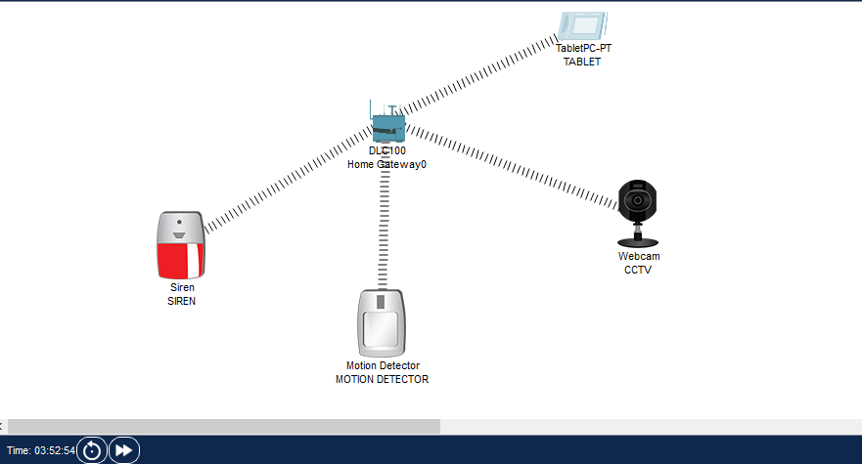

Motion Detector is used for detecting any sort of motion. Home Gateway is providing network access to motion detector, siren, webcam and tablet. Siren is turned on when motion detector detects any kind of motion while the webcam will start recording the video. This type of IoT Smart Device is especially used in banks where there is a risk of robbery. These systems keep a track and continuously monitors any activity, through tablet it’s monitored, we can also generate notifications through API for timely and immediate response.

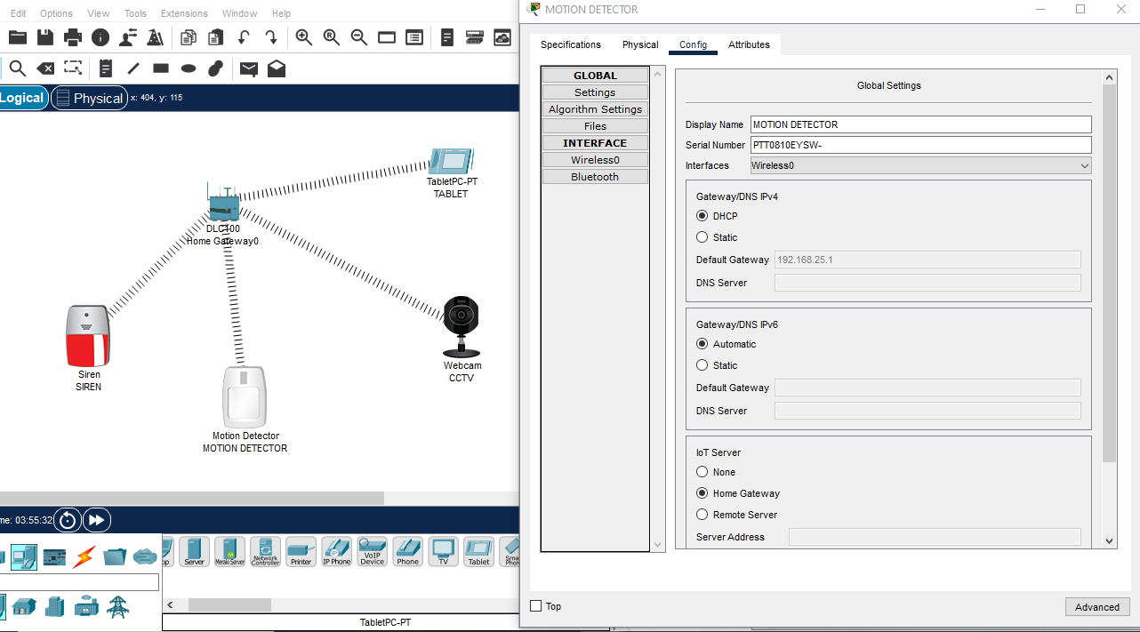

All the devices (Motion detector, siren, webcam, and tablet) are connected with the IoT server that’s Home Gateway. Home Gateway is used for providing network access to all these devices.

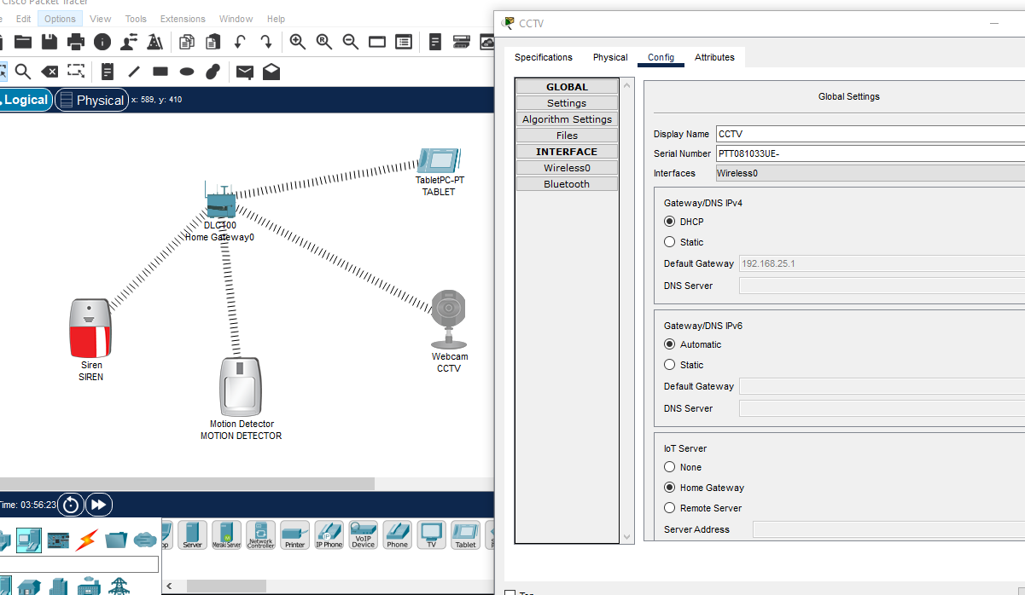

**CCTV and Siren also connected to home gateway IoT server**

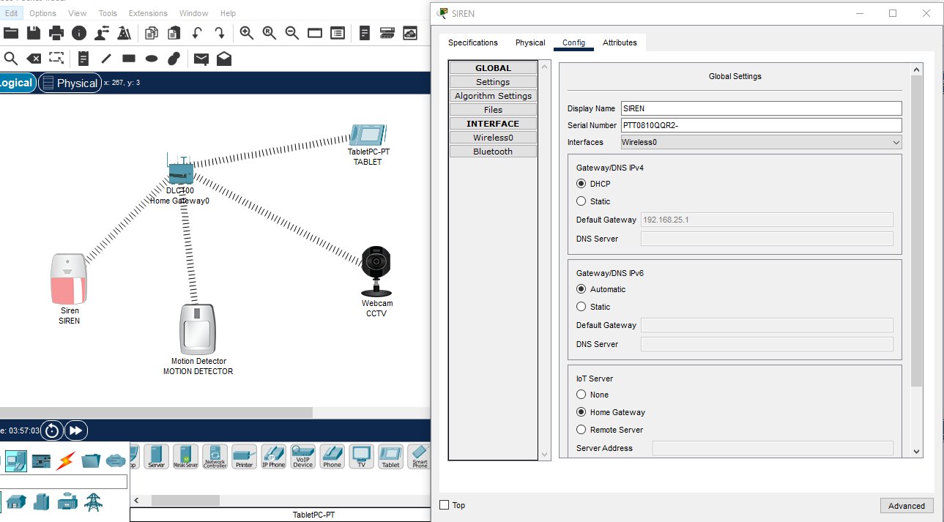

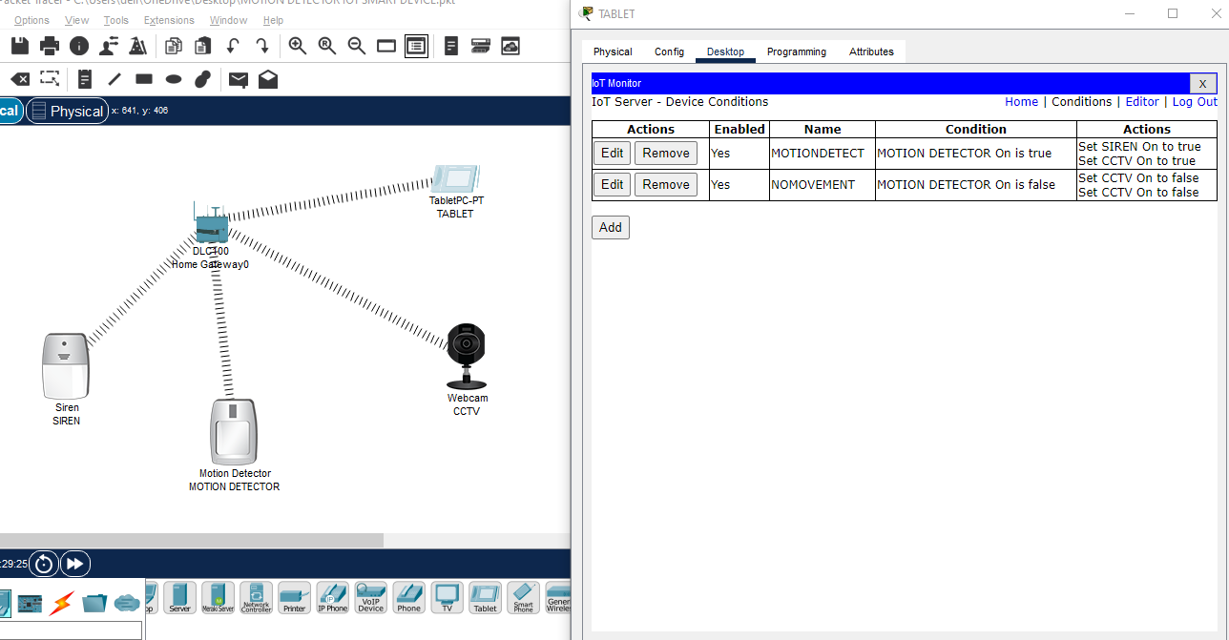

**Device Conditions:**

**Siren & webcam will be turned on when motion detector detects any motion and will be turned off automatically when there is no motion.**

**This is showing when we click on the motion detector, it senses motion and its turned on. The siren is also turned on and automatically the webcam starts recording the video as well as shown in the figure. All this can be monitored and seen on the tablet connected with the devices.**

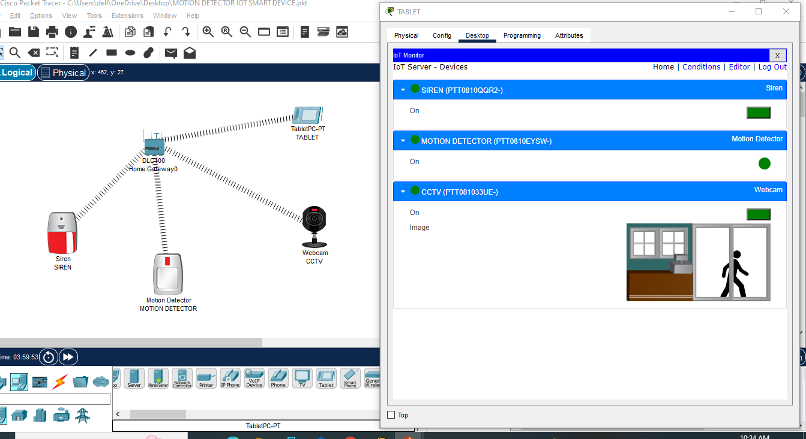

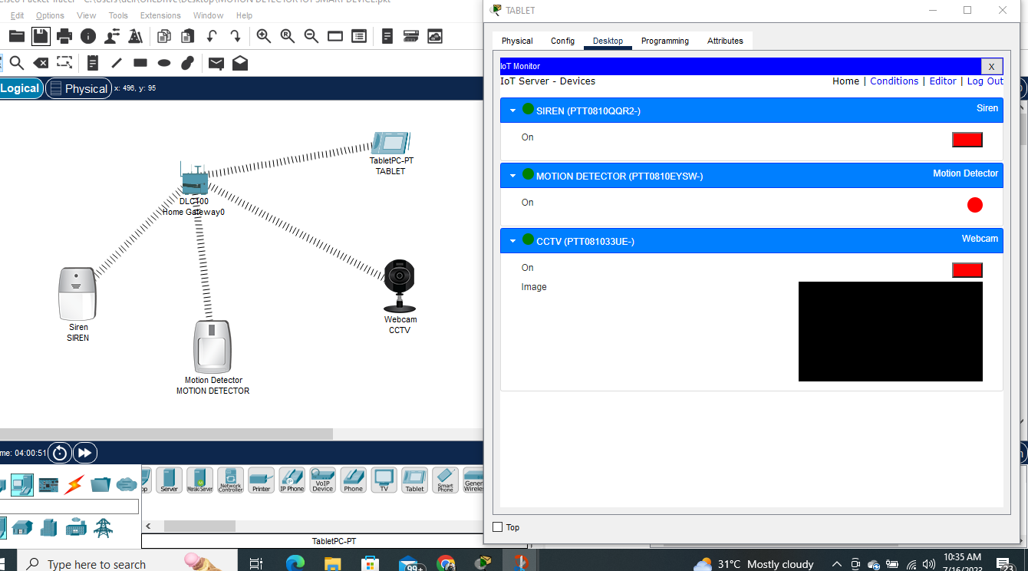

**Demonstrating that when the cursor moves away from the motion detector, its turned off, siren is also turned off and the webcam also switches off.**

**YOU ARE A CHAMPION! SUPER CHAMPION! :)**